Math 740/840 Homework Assignment #5 Fall 2019

Due 11/13/2019

1. (20 pts.) To generate the Bayesian I optimal design, open Custom Design, next open the main report menu and select the **Load Factors** option. Navigate to location where you downloaded the file **Trébuchet Experiment Factor Table.JMP** and select the file; this file populates the Factors table with the seven continuous factors.   
   1. Your first task is to use the virtual trebuchet and find low and high settings for each of the 7 continuous factors. Our goal is hit target distances of **250** feet, so find low and high settings such the range of launch distances extends below and above 250 feet. Once you have found your low and high settings take a screenshot of the Factor Table and include it in your report. **Important:**  In finding high and low settings for your 7 factors keep in mind that at some settings the trebuchet may not function correctly and possibly not even return a distance measure so in picking settings make certain that the trebuchet actually works at those settings – this can be an issue in any experiment where some settings of equipment do not work and we want to find this out before doing the full experiment.

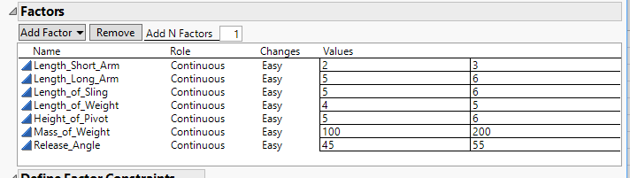

* 1. Next, define the model in the **Model** window; click on the **RSM** tab to create a full quadratic model (we will discuss the model in detail later in the course), which contains the main effects, quadratic effects, and all 2-way interactions. Change the **Estimability** value for **the 2-way interactions only** to **If Possible**; see the Screening Designs Part 2 notes for an explanation of the **Estimability** column. The other terms should be left at the **Necessary** value. Finally specify the number of runs as 20 and do not include center points. Please include a screen shot of your **Model** and **Number of Runs** displays.  
     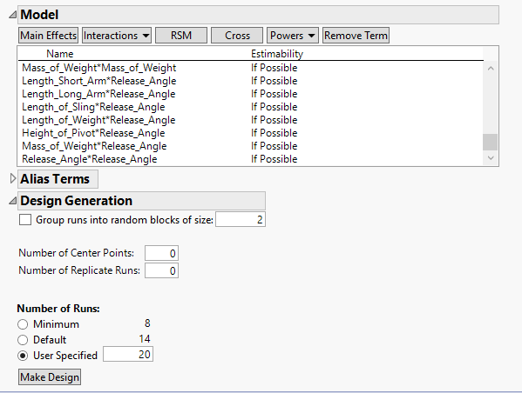
  2. Beneath the Model window you will see the **Alias Terms** window (click on the disclosure icon to open it). In this window click on the **Interactions** tab and select **2nd**. The window should now display all 21of the 2-way interactions. We need the Alias Terms defined for the Alias Matrix to be shown later. At this point click on the **Make Design** button to have JMP generate the design. Remember optimal designs are not unique so many students will get different designs.
  3. Once the design is created click on the **Design Evaluation** disclosure icon to open the report. Within the report find the **Alias Matrix** report and click on the disclosure icon to open. Include a screenshot of the Alias Matrix in your solution. After examining the Alias Matrix, discuss briefly whether or not this is an **orthogonal design**. Finally click on **Make Table** to create the JMP data table.  
     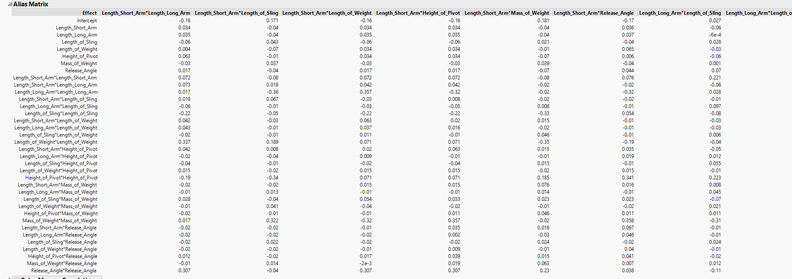

**The alias matrix shows that the overall design is not orthogonal as the design relies on other factors, where which an orthogonal design can be evaluated independently of all other factors. The combination of the two-way interaction does affect the overall design.**

* 1. Now go to the Virtual Trebuchet website and enter in the settings for each of your 20 trials and record each of the launch distances. Please provide a screenshot of your completed data table.

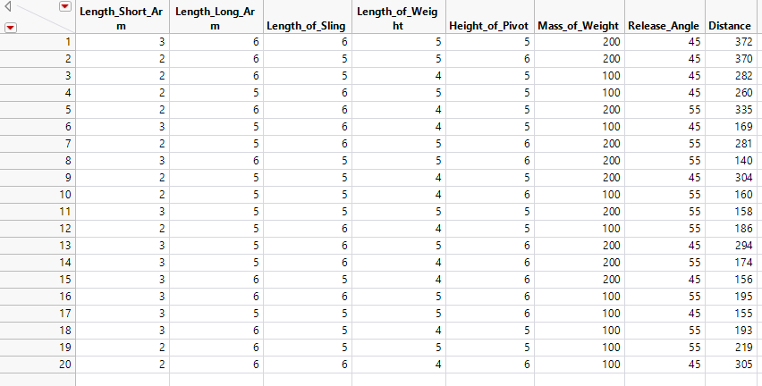

1. (15 points) Using the data from problem 1 we are ready to analyze the experimental results using JMP. We will use the **Stepwise** platform in JMP to perform **Forward Selection**; see the **Screening Designs Part 3** notes.  
   1. In the Fit Model platform (**Analyze 🡪 Fit Model**) JMP should automatically define a full quadratic model. If it does not do so, then highlight the 7 factors in the **Select Columns** window, then click on the **Macros** button and select **Response Surface** from the options. Change the fitting **Personality** to **Stepwise**, the Personality button is in the upper right hand corner (it displays Standard Least Squares by default).
   2. Once in the Stepwise platform window, first fit a model using **Forward Selection direction** and the stopping rule set to **Minimum BIC**. Click on **Go** to generate the model. Finally click on the **Run Model** button to open a **Fit Group**.
   3. Click on **Remove All** button to remove the selected terms from part b. Next set the stopping rule to **Minimum AICc** and click **Go** to generate the model. Click on **Run Model** to add this new model to the **Fit Group**. At this point you can close the Stepwise platform.   
        
      For the two models you added to the **Fit Group** select the **Actual by Predicted** plot option and **PRESS** option (under the **Row Diagnostics** option in the main report menu). Please include a screenshot of your two models in your solution and comment on the fit of the models (is there evidence of lack of fit or over fitting in either model?). In terms of the PRESS statistic which model seems to predict Distance better?  
      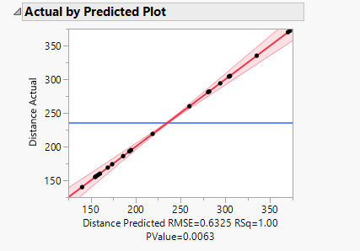

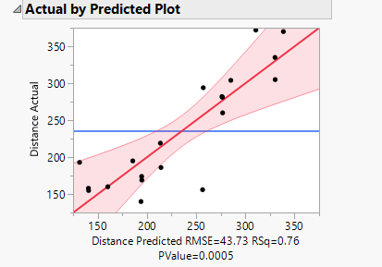

**From the two graphs, the first being minimum BIC and the second being AICc, it is obvious that the first one seems to predict distance better as the Rsq value is 1.00, while the second one is at 0.76.**

* 1. The final step is to save each of the two **Prediction Formulas** to the data table. To do this open the main report menu and from the **Save Columns** submenu select Prediction Formula. You will need the two formulas stored as columns in your data table for part 3 of this assignment.

1. (10 pts) Once you have fit the two models in problem 2, we will use each model to determine settings of the catapult factors to hit specified targets. Since you have saved both Prediction Formula to the data table, we will use the Profiler directly from the data table without Fit Model; see page 41 of the Screening Designs Part 4 notes. The Profiler platform is located under the Graph menu (**Graph 🡪 Profiler**). Do one model at a time, so there should be two separate Profiler reports.  
   1. For each model, in the Prediction Profiler report menu select the Desirability Functions option. Next, click in the Desirability Profile window that appears on to the right of the Profiler and in the Response Goal window change the response goal to Match Target and set the target (middle value) to 250. Now select the Maximize and Remember option from the Profiler report menu to find the settings that will produce the target distance. Include a screenshot (or use Selection Tool) to show the Prediction Profiler configuration and the suggested factor settings to hit a target of 250. Record the suggested settings for each of the two models.  
      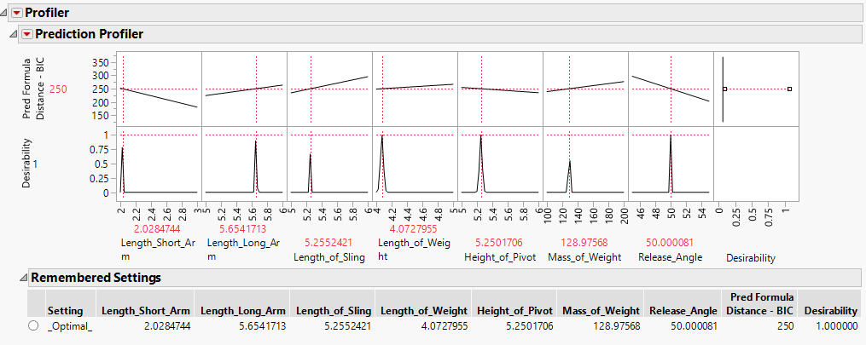

**Above is the graph for BIC**

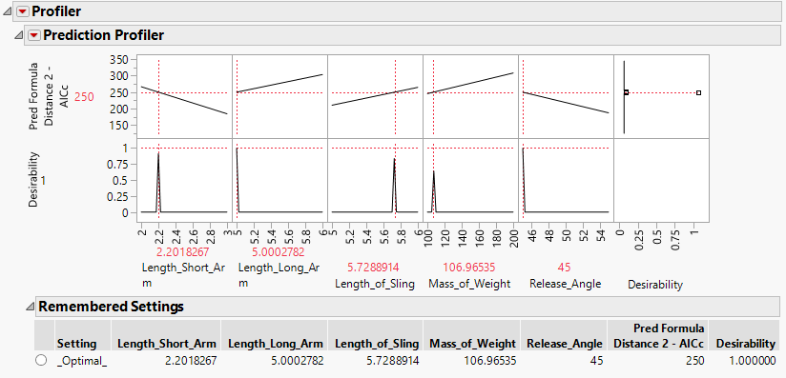

**Above is the graph for AICc**

* 1. For each model run the trebuchet at the optimized settings. How close was the actual distance to the predicted distance of 250 for each model? Does one model seem to be closer than the other? Comment.  
     **BIC – 274 feet**

**AICc – 237 feet**

**The models seem to be relatively as accurate. When altering one number a very small amount, the amount of distance it outputs is much higher, which makes me think that the simulation has a few bugs in it that can affect the overall reliability of the output of distances from given parameter inputs.**

* 1. Repeat parts a and b, but this time in the Prediction Profiler specify a target distance of 300. Include a screenshot of the Profiler with the suggested factor settings. How close did the actual distance come to 300? Compare the results in part b to the results in this section. Are the results similar?

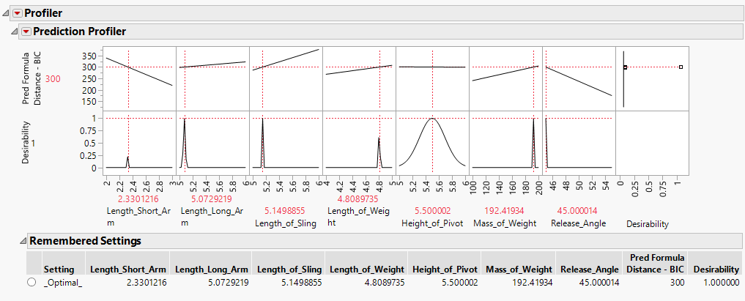

**This is for BIC ^**

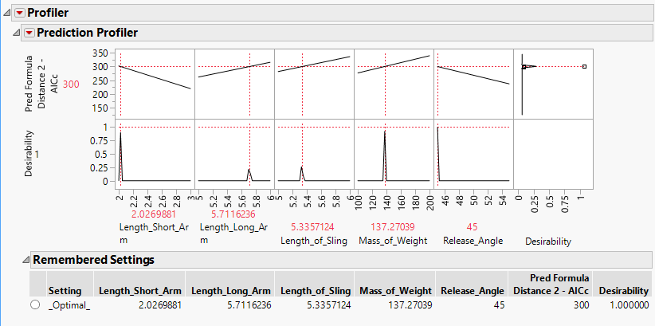

**This is for IACc**  
  
**BIC – 202 feet**

**AICc – 303 feet**

**This result was surprising, it seems that the BIC feel a lot in accuracy from this different target, and the IACc was much better in predicting what would actually output the distance.**